**Chapter Four – Part III**

**ASSESSMENT MANAGEMENT SYSTEM**

1. **Introduction**

Assessment is one of the learning activities that can be achieved electronically and via mobile devices. Assessment Management System (AMS) is part of LMS that is responsible for providing, managing, automating, and facilitating the assessment process. Mobile assessment adoption in current LMS requires architectural modifications to reflect interoperability characteristics required by mobile supported processes. Mobile Learning (M-Learning) is an approach to E-Learning that utilizes mobile devices and should be enabled by educational institution Learning Management System (LMS). Unfortunately, M-Learning is not the same at all educational institutions. Mobile assessment refers to the capability of conducting assessments via mobile devices. Mobile assessment relies on external services that are not part of the LMS.

1. **AMS Analysis**

Mobile assessment utilizes mobile services architecture to deliver interactive messaging automatically. Interactive messaging include sending assessment questions and receiving multiple responses SMSs. Figure 4.26 presents Mobile Services Architecture required to enable learners to interact via mobile SMS with LMS that resides in university server. Mobile services architecture can have different implementations. Understanding the mobile service architecture is critical for the design and implementation of LMS.

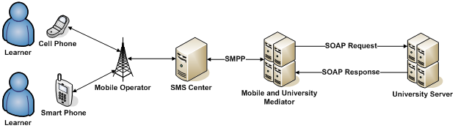

Figure 4.26: Mobile Services Architecture

Learner is connected to her/his mobile service provider via cell or smart phones. Mobile operators implement one or more SMS centers. Those are centers that manage sending and receiving of SMSs. University needs a mediator in the way to SMS center. Mediator lies in the middle between mobile operators and LMS. Mediator connects directly to different SMS centers using Short-Message Peer-to-Peer (SMPP) protocol. SMPP is a telecommunication industry protocol for exchanging SMS messages between SMS peer entities such as SMS center. It is often used to allow third parties to submit messages in bulk. SMPP has been designed to offer services for various cellular networks such as GSM, CDMA, and TDMA. Mediator is connected directly the University server over the Internet, via standard Web services. Mediator receives and sends SMSs and exposes two Web service that give LMS the capability to access SMSs received, and to send SMSs. Via SOAP request, university can receive SMSs aimed to it, and via SOAP response, university can send new SMSs. University LMS should manage sessions with different users, utilizes data within SMSs in managing learners profiles. LMS shall maintain a record of all sent and received SMSs for managerial, financial, and educational issues. Proposed extended LMS addresses a new added process namely Take Mobile Assessment as depicted in the use case diagram at figure 4.27. Figure 4.28 presents AMS entities.

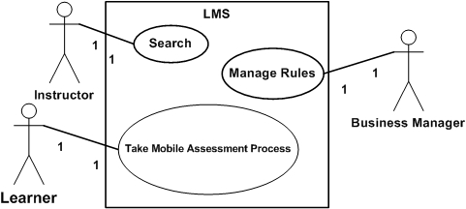

Figure 4.27: AMS Use Case

Figure 4.28: AMS Entities

* 1. **Proposed AMS Architecture**

Proposed architecture as presented in figure 4.29 consists of two layers: Interface layer, and Service layer. Interface layer interacts with instructors, learners, and business managers via human interface, that is portals, and with external organization services via machine interface, that is Web services. Service layer contains core LMS services and has three sub layers: Orchestration, Application Services, and Agents layer. Orchestration layer holds business logic presented by system processes as executable services. Business logic refers to different activities that can include Web services invocations, data manipulation, exception handling, and process termination. Application Services layer contains set of stateless Web services that are capable of performing certain tasks related to system entities. System entities reflect distinguishable objects within system that should be reflected in the LMS, like instructors, courses, and assessments. Web services are stateless because they can not maintain business logic, operation flow, or user state. Agents layer presents the suggested required software agents to serve the overall system. Agents layer presents Tracker software agent that keep track of learner assessments due dates.

**2.2 Take Assessment Process Analysis**

Figure 4.30 presents Take Mobile Assessment process analysis. Take Mobile Assessment process is initiated by learner, managed and maintained by Assessment Manager, and Session Manager. Assessment Manager and Session Manager are both Orchestration layer services. Managing and maintaining take mobile assessment process refers to keeping track of assessment items retrieved, validating learner's answers, handling exceptions, and maintaining actions sequence and Web services invocations. Figure 4.30 implicitly defines LMS boundary for take mobile assessment process. Out of LMS scope refers to activities fall outside LMS boundary and can not be maintained, neither controlled by LMS. Activities related to mobile operators and mediators are out of LMS boundary. LMS scope activities are handled, maintained, and controlled by LMS. Take Mobile Assessment process begins for LMS once it retrieves SMS that is aimed for assessment. Take Mobile Assessment process is an example of processes that contain activities outside organizational boundaries.

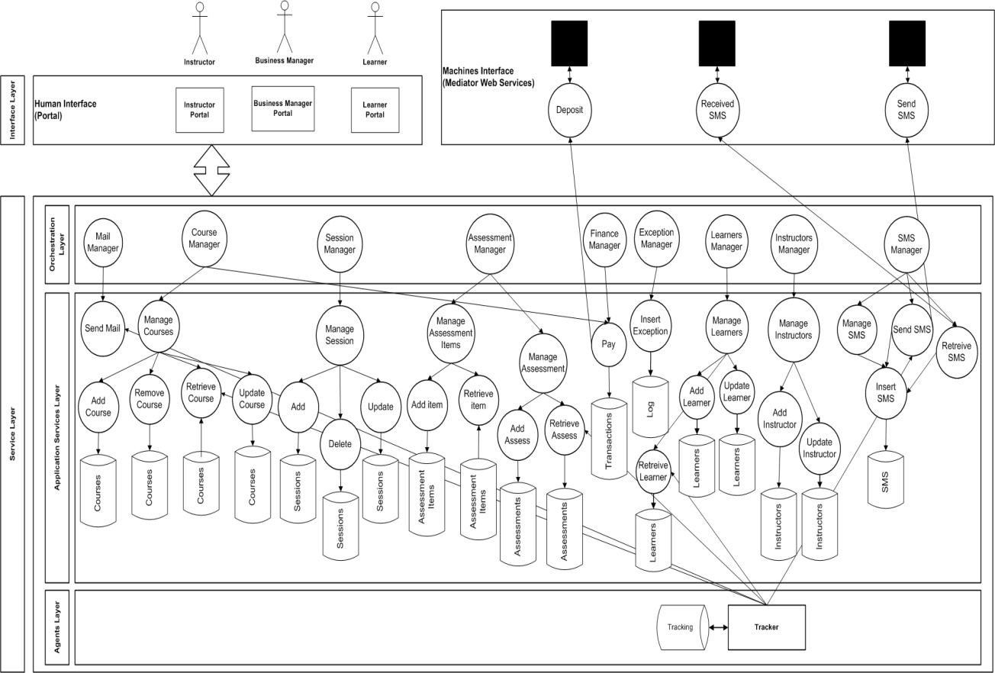

Figure 4.29: Proposed AMS Architecture

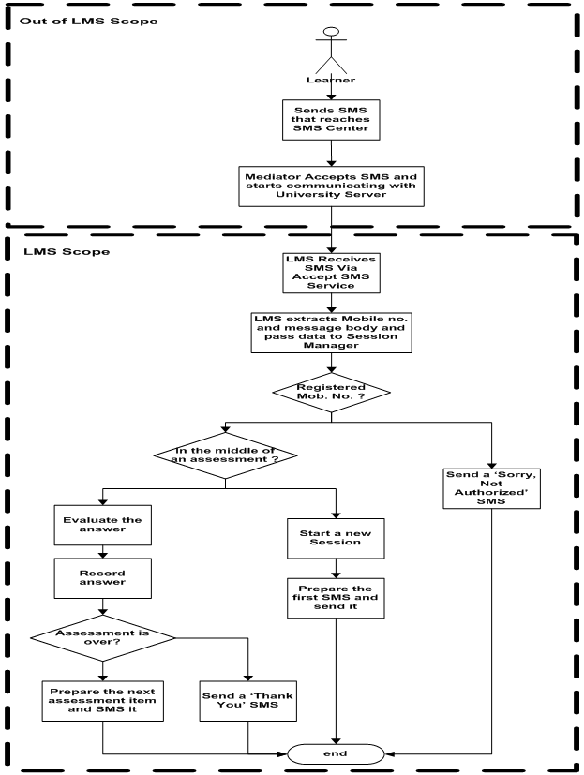

**Figure 4.30: Take Mobile Assessment Process Analysis**

**2.3 Tracker Agent**

The role of software agents in tracking users’ activities has been widely known and accepted. Figure 4.31 illustrates analysis of tracking process. Tracking process is initiated and performed by tracker agent and aims to track learners missing assessments and take some action to remind students with due dates of assessments. Tracking process consumes five Web services: Read Learner Data, Read Course Data, Read Assessment Data, Send Mail, and Send SMS.

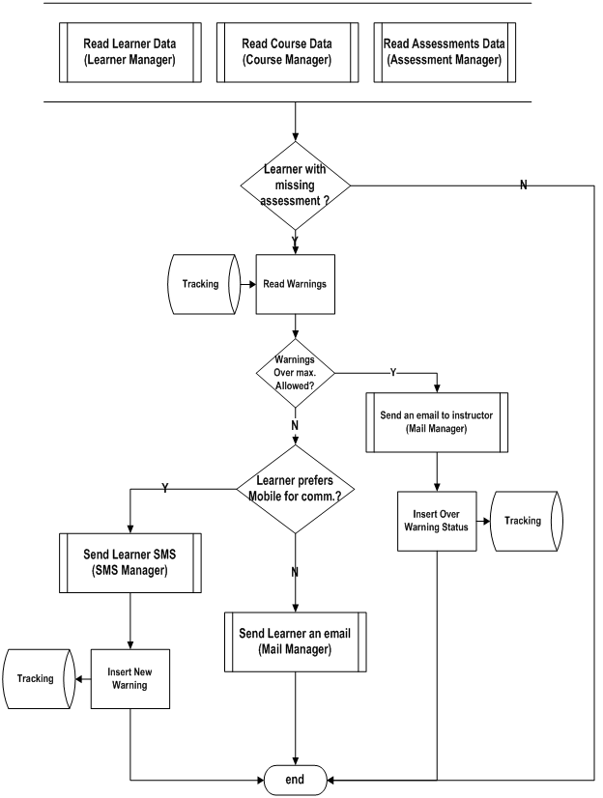

**Figure 4.31: Tracking Process Analysis**

1. **AMS Design**

AMS design task includes automating the new added process, and designing the required software agent. Automating take mobile assessment process includes partitioning the process into reusable services, designing services, and designing database tables required to support each service.

**3.1 Take Mobile Assessment Process Design**

Figure 4.32 presents Take Mobile Assessment Process design. Take Mobile Assessment Process is managed and maintained by assessment manager, and session manager. Take mobile assessment process utilizes Web services namely: Manage SMS, Manage Learner, Session Manager, Manage Assessment Items, Manage Session, and Insert Exception. LMS services can be reused to serve different processes. Design of Manage SMS, Manage Learner, Manage Assessments, Manage Assessment Items, Manage Sessions, and Session Manager Services are presented in details.

**3.1.1 Manage SMS Service Design**

Manage SMS presents a collection of services that include Retrieve SMS, Send SMS, Insert SMS, and Delete SMS. Retrieve and Send SMS are two services that map mediator exposed Web services. LMS maps exposed mediator’s Send and Receive SMSs Web services into internal Retrieve and Send SMS. When LMS invokes both services, it is actually invoking Mediator’s Send and Receive SMS services. This mapping is tended to act as an isolation layer to enable changing mediator upon need. Insert SMS keeps a log of all received and sent SMSs. LMS maintains a record of all sent and received SMSs for managerial, financial, and educational issues. Records can be used to calculate fees to be paid for mediator monthly according to usage statistics. Figure 4.33 shows the required database table for Insert SMS service that is invoked every time a SMS is sent or received. Delete SMS utilizes the same database table and is invoked periodically to clear SMS record from too old SMSs based on date and time basis.

**3.1.2 Manage Learner Service Design**

Manage Learner encapsulates the three primary database operations insert, update, and delete. Learners’ data and profiles are maintained and updated based on attended assessments. Figure 4.34 presents required database tables to maintain learners’ data and profile. Course_Assessments table holds assessments of each course. Learner_Courses table holds courses attended by each learner. Learner_Assessments table holds assessments attended by learner, and related data like student score for this assessment, date, and time student attended the assessment.

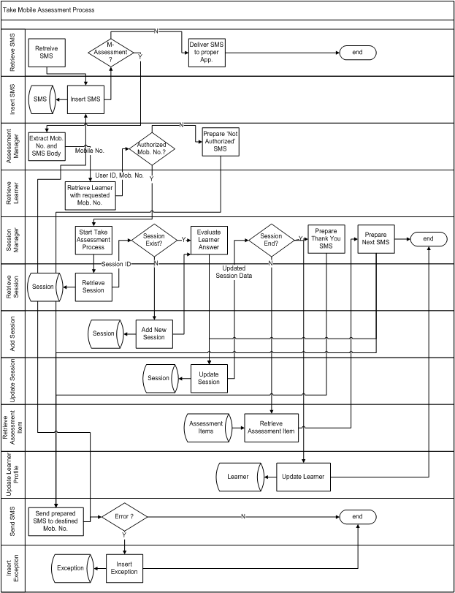

Figure 4.32: Take Mobile Assessment Process Design

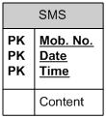

Figure 4.33: Table of Insert SMS Service

Assessment dates are stored, so LMS can determine learners missing assessments to be inserted in missing_assessments table. Learner_Missing_Asse table holds assessments that learners should have attended but they did not. Learner_Missing_Asse is used by tracker agent to remind students of missing assessments.

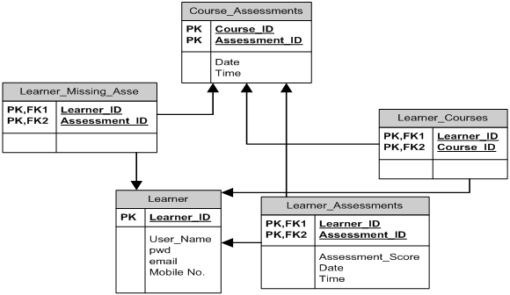

Figure 4.34: Tables of Manage Learner Services

**3.1.3 Manage Assessments Service Design**

Figure 4.35 shows required database tables to store and manage assessments. Manage assessments service is concerned with the three main database operations insert, update, and delete assessments themselves, not assessment items. Assessments should contain variant difficulty levels of assessment items. Assessments are categorized according to difficulty level into easy, medium, and difficult. Instructor is responsible for categorizing difficulty level of each assessment from educational perspective. An automated assessment categorization can be achieved via calculating percentage of difficult, medium, and easy assessment items composing the assessment.

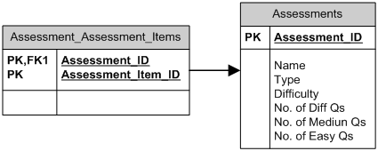

Figure 4.35: Tables of Manage Assessments Services

**3.1.4 Manage Assessment Items Service Design**

Assessment items are the main factor of assessments to either achieve required goals or not. Assessment items need to be well prepared to enable assessment efficiency. Assessment items are stored and managed separately to form an assessment items repository. Assessment items repository enable sharing assessment items among different assessments to overcome interference of topics among courses and to enrich assessment items bank. Sharing assessment items among assessments is done under instructors’ supervision. MCQs, True/False, and Complete the missing word are examples of applicable mobile assessment items. From assessment items difficulty point of view, LMS has three classes: easy, medium, and hard. Assessment item difficulty level is determined by instructor either while inserting or updating assessment item. Figure 4.36 depicts the required database tables for manage assessment items service.

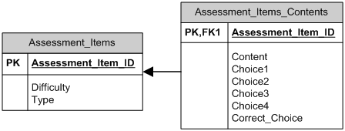

Figure 4.36: Manage Assessment Items Services

**3.1.5 Session Manager Service Design**

Session refers to the period of time in which the same user interacts with the system. Mobile user interacts with the system via multiple discrete responses. Web services are stateless, and sessions are needed to enable stateless protocols to track user interaction with the system. In LMS, Session refers to the period of time the learner is identified by the system as in the middle of a process. Session managers maintain users’ interactivity data temporarily in the database. Session Manager Service holds the business logic required to enable the supported processes. Temporary database accesses are left to manage session service. Session manager activities include recognizing either the learner is in the middle of an assessment or attempting to a new one, and then invoking the suitable Web services based on user state. Some of the Web services session manager invokes are add session, update session, update learner profile, and send SMS.

**3.1.6 Manage Session Service Design**

Manage session service is responsible for performing the three main database operations insert, update, and delete sessions. Figure 4.37 shows the required tables for manage session services. Session data include a unique session ID that becomes available for reuse when session ends, Learner ID that reflects the learner unique ID stored for each learner, learner mobile number, and score of the learner in the assessment. Score increases when learner correctly answer assessment item. Another database table is required to keep track of assessment items sent to the learner during the session, so sending of repeated assessment items is avoided.

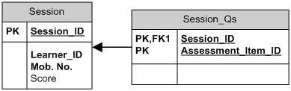

Figure 4.37: Tables of Manage Session Services

**3.1.7 Manage Exception**

Exceptions refer to non-ordinary flow of events or actions. Well defined information systems should address and handle exceptions carefully. Feed forward information systems needs to keep record of exceptions took place to be analyzed. Software agents can perform analysis functions on recorded exceptions. Figure 4.38 depicts the database table required to keep exception log. Exception log is available for business manager and system administrator to maintain system state. Figure 4.39 shows the overall implemented Assessment Management System database tables.

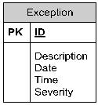

Figure 4.38: Table of Insert Exception Service

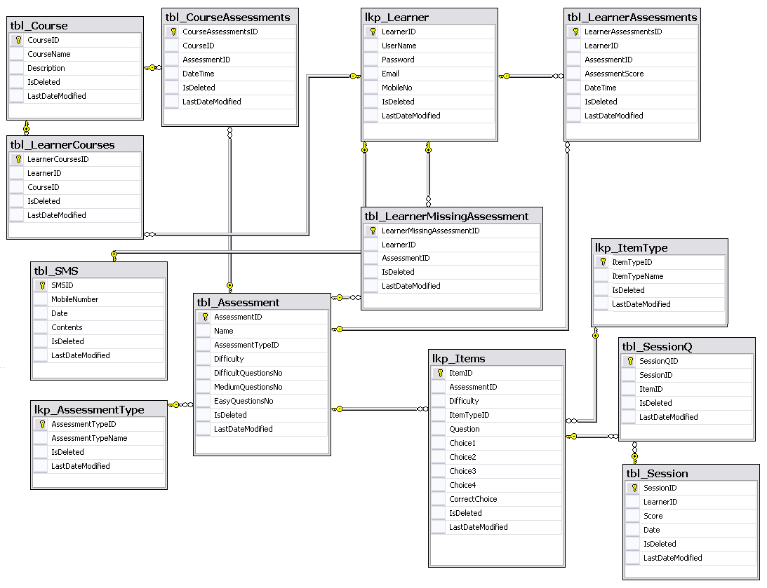

Figure 4.39: Overview of AMS Database Tables

**3.2 Tracker Agent**

Tracking process consumes five Web services: Read Learner Data, Read Course Data, Read Assessment Data, Send Mail, and Send SMS. Figure 4.40 presents the database table required for tracker to keep track of current submitted learners warnings, and the maximum number of allowed warnings. Tracker agent gets information about the learner missing assessments by utilizing the manage learner.

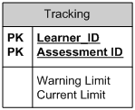

Figure 4.40: Table of Tracker Agent

**3.3 AMS Classes**

Figure 4.41 presents Services layer SMS Manager class diagram. Figure 4.42 depicts Assessment Management System class diagram,

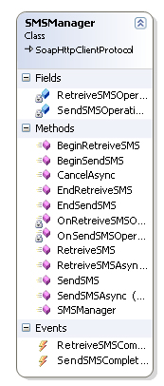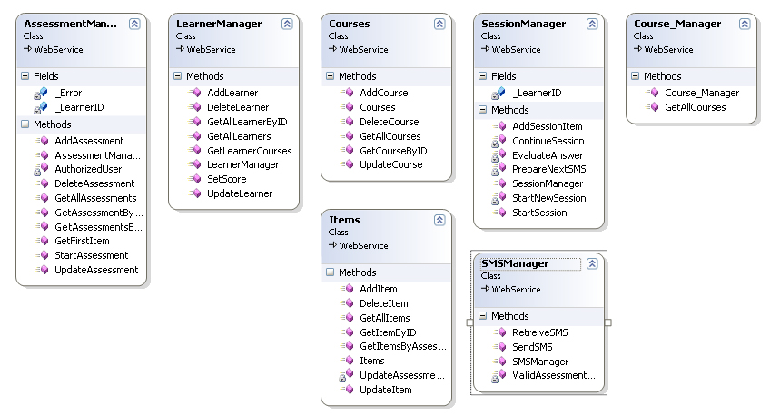

Figure 4.41: Service Layer and SMS Manager Class Diagram

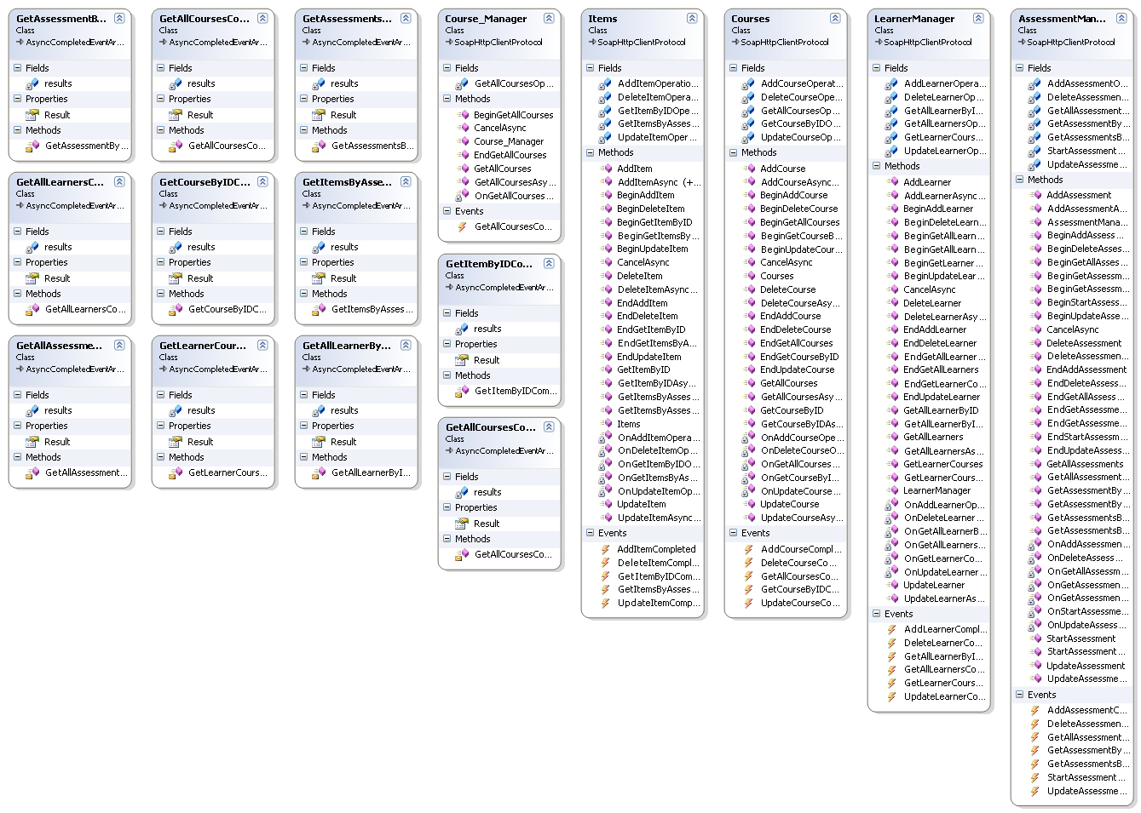

Figure 4.42: AMS Class Diagram

1. **Mobile Simulator Interface Design**

Figure 4.43 shows the mobile simulator interface available via the portal to test the AMS mobile functionality.

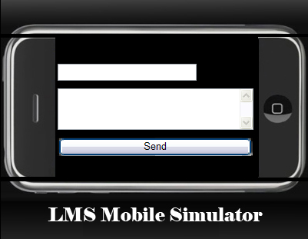

**Figure 4.43: Mobile Simulator**

1. **Learner interaction with LMS**

Take Mobile Assessment process relies on the sequence of SMSs learner sends and receives with the LMS. Figure 4.44 shows a classical interaction between learner and Assessment Management System during the take mobile assessment process. Highlighted shapes present SMSs sent by learner, and other shapes present SMSs received. Learner sends SMS with assessment ID, receives the first assessment item, responds with the appropriate choice, and finally receives a summary with the result. The receive assessment item and response sent by learner operation is repeated as many times as assessment items for each assessment.

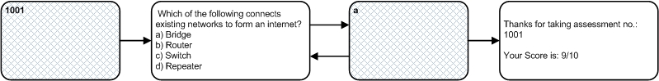

Figure 4.44: Classical Learner – AsMS Mobile Interaction

1. **Summary**

Assessment is an integral part of the learning process, and a learning activity that can be achieved efficiently via mobile devices. Due to differences in mobile architectures, and as a result of lack of interoperability in current commercial LMS with external systems, mobile assessment may find difficulties in implementation. SOA as a design pattern addresses non functional requirements like interoperability and integration to achieve systems agility. SOA utilizes Web services as main enabler to achieve addressed design goals. Interoperability is a main challenge for systems adopting and interacting with external components that. Interoperability between LMS and mobile mediator is achieved via adoption of Web services based SOA in LMS. SOA provides a fine granularity and modularity via standard interface that solves integration and interoperability challenges, but adds complexity to systems design. Pedagogically, mobile assessment is important due to the assessment importance process to the learning process. Mobile assessment facilitated and encouraged learners to attend assessments and enabled distance education by expanding interactivity tools available to learners to include mobile devices.

1. **Interface Design**

Figure 3.22 shows the mobile simulator interface available via the portal to test the assessment management system mobile functionality. Figure 3.23 presents Assessment Management System entities. Extended Assessment Management System Design is available in Chapter 4 – Par I.



**Figure 3.22: Mobile Simulator**

Summary

Assessment is an integral part of the learning process, and a learning activity that can be achieved efficiently via mobile devices. Due to differences in mobile architectures, and as a result of lack of interoperability in current commercial LMS with external systems, mobile assessment may find difficulties in implementation. SOA as a design pattern addresses non functional requirements like interoperability and integration to achieve systems agility. SOA utilizes Web services as main enabler to achieve addressed design goals. Interoperability is a main challenge for systems adopting and interacting with external components that. Interoperability between LMS and mobile mediator is achieved via adoption of Web services based SOA in LMS. SOA provides a fine granularity and modularity via standard interface that solves integration and interoperability challenges, but adds complexity to systems design. Pedagogically, mobile assessment is important due to the assessment importance process to the learning process. Mobile assessment facilitated and encouraged learners to attend assessments and enabled distance education by expanding interactivity tools available to learners to include mobile devices.